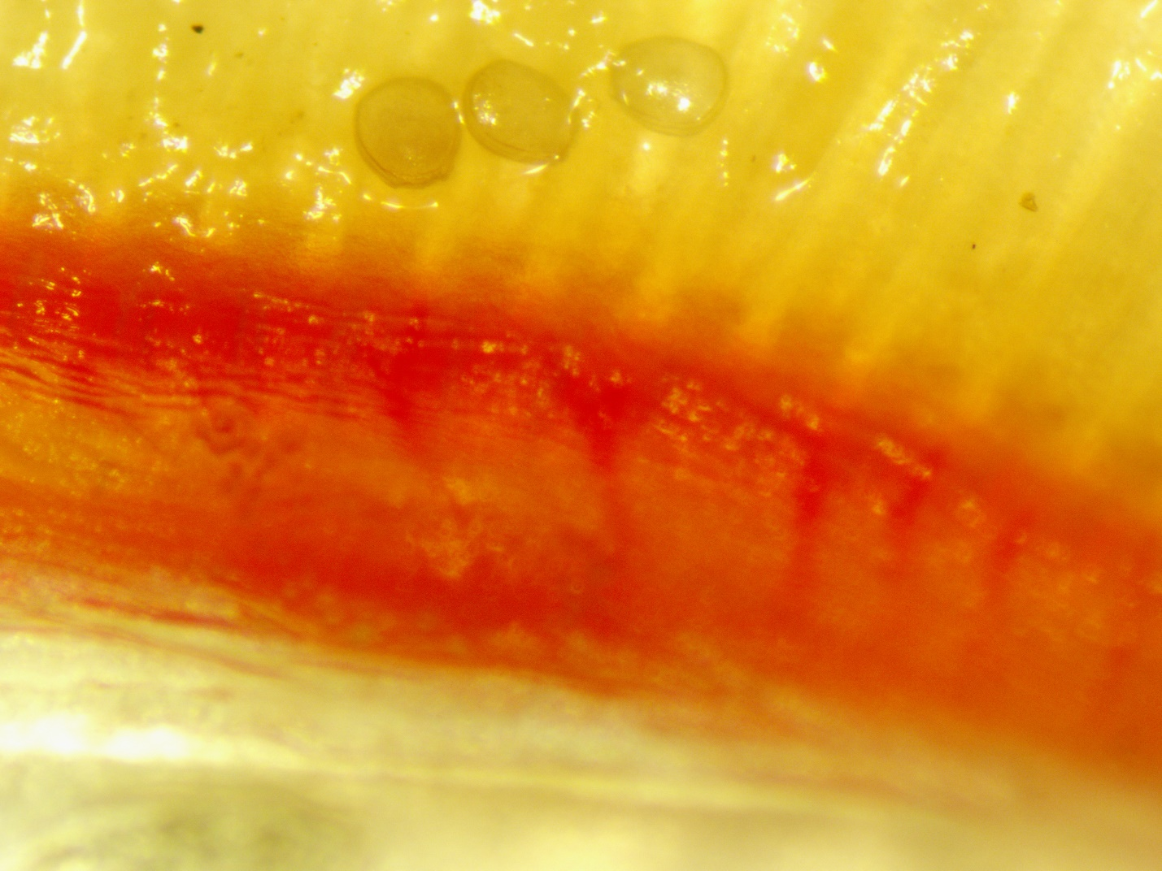

Largemouth Bass gill with mussel glochidia attached

Juvenile Yellow Lampmussel